THE CHINESE UNIVERSITY OF HONG KONG, SHENZHEN
Registry Office
Record Form for Change of Course Grades

Student Information
Student Name: [in English] ____Wang, Yuchen_________ |  | [in Chinese] ________王雨晨__________________
Student I.D.: ______119010320___________________ |  | School: _____SDS________________________
Course Information
Course Code: ____CSC4005______________________ |  | Course Title: Parallel Programming
Offering Term: AY2022-2023 Term 1 |  | Offering School: _______SDS________________
Course Instructor/Course coordinator: ____Prof. Chung Yehching_ ____________________
Original Grade: _______F____________________ ___
Revised Grade: _______D________________________
Reason(s) for the change:
 | In my grading policy of a couse, a copy or copied programming assignment is not allowed. TA will check if there are copy or copied cases. For the case of Yucheng Wang, he put his programs at Github to make the use of file transfer easier in between his laptop and the desktop at the PC rooms. However, he did not make his files at Github as private. Therefore, one of his classmates download his code and handed in the code to TA. When TA informed him that his code is the same as one of his classmates, he was stunned. he told the TA that he did not give the code to his classmates and described his strategy of using Github. TA told him that he should make his files private to prevent others looking at his codes since the default setting of Github is public. Since he did not know the default setting of Github and made a mistake, he got zero point from this programming project. The programming project will occupy 70% of the final grade, that is, each programming project will occupy 17.5% of total score of a course. For my grading policy, students can get 60 points for the hand in programming project if there has no compilation errors of the handed in codes. It means that Yucheng should get 10.5 points for his final grade from this programming project. Considering he did not know the default setting of Github, the mistake is tolerant. Therefore, I would give 60 points for this programming project. In this way, he could get grade D instead of F from this course.
[Continue on a separate sheet if necessary]
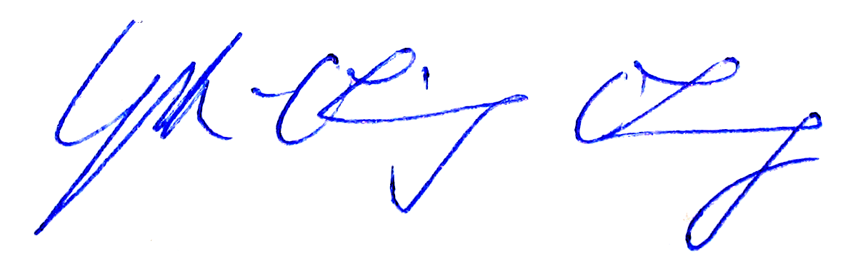

____________________________________________________________ _____ _2023.05.16_ _
Signature of the Instructor/Course coordinator Date
____________________________________________________________ ___________________________
Signature of the School Dean or the Chairman of SAP Date

